S
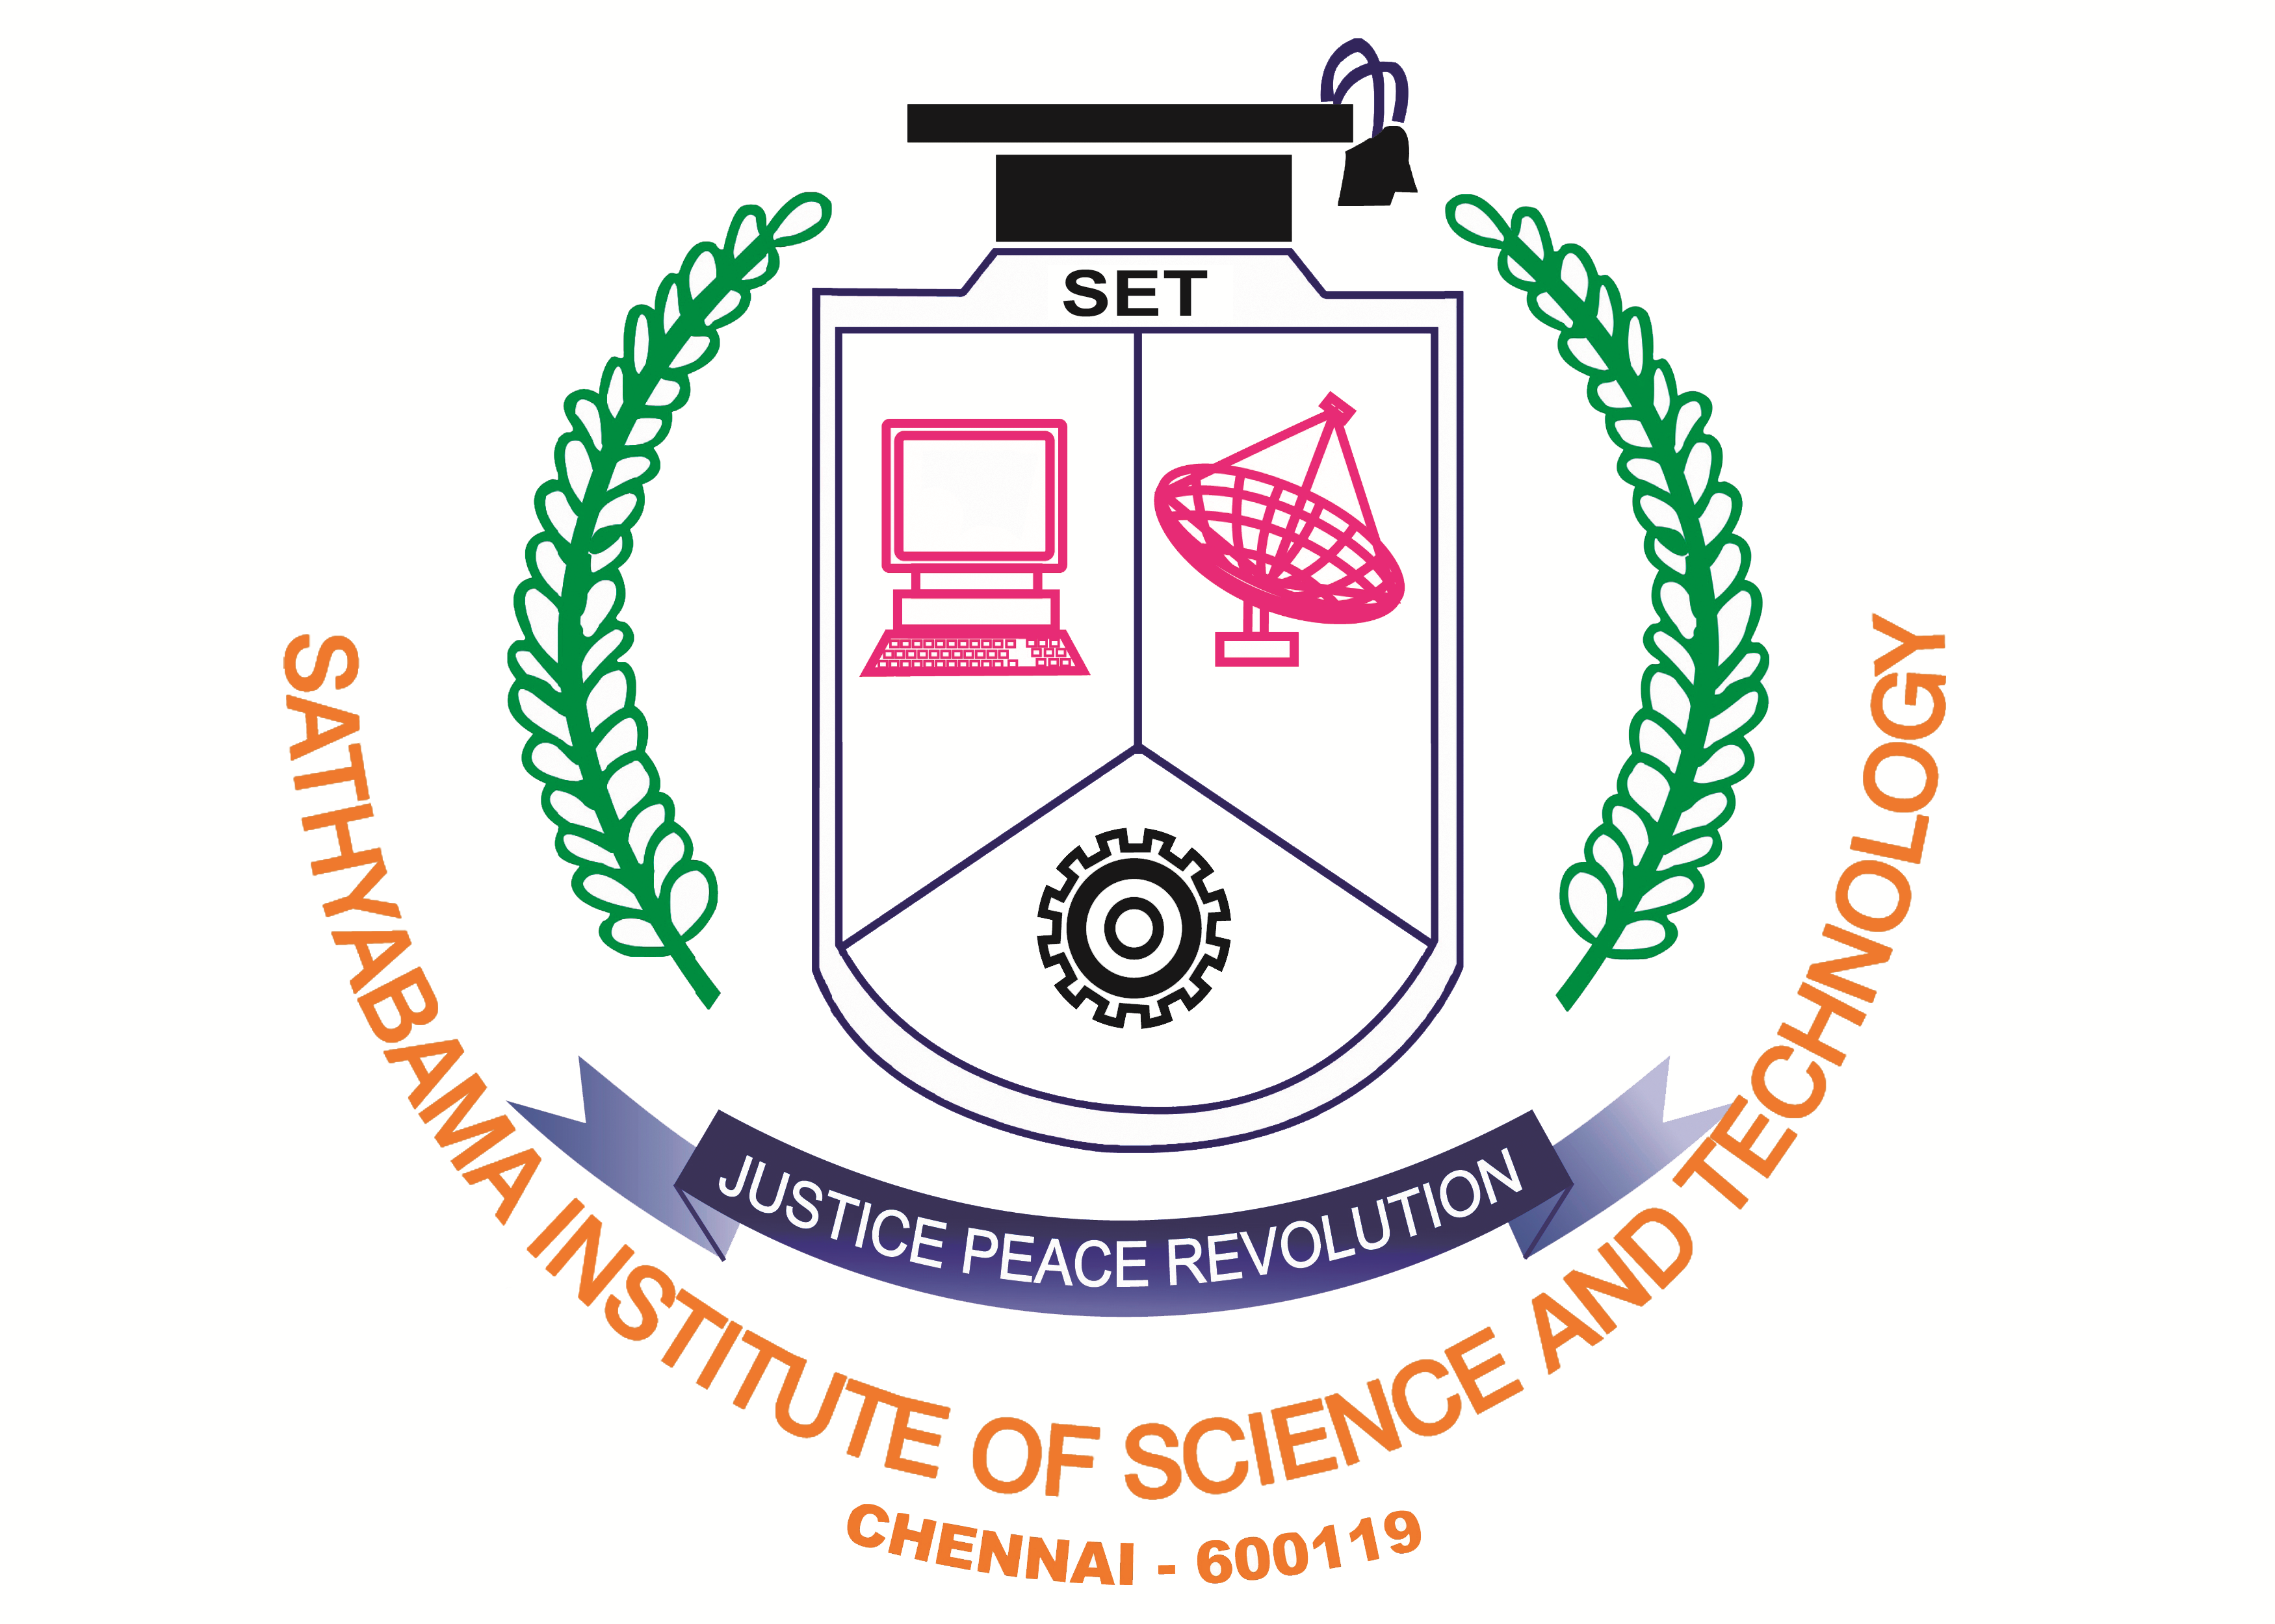
SATHYABAMA
INSTITUTE OF SCIENCE AND TECHNOLOGY
(DEEMED TO BE UNIVERSITY)
(Established under Section 3 of the UGC Act, 1956)
Accredited with ‘A’ Grade by NAAC
Rajiv Gandhi Road, Jeppiaar Nagar Chennai – 600 119, Tamilnadu. India.
Phone: +9144-24502736/24503065/ Fax: +914424503814
Email: internationalrelations@sathyabama.ac.in



Application Number: _____________________ (for office use)

Affix Recent Passport Size Color Photo

ENGINEERINGMANAGEMENTARCHITECTURE
ARTSSCIENCEDENTAL LAW

COURSE & BRANCH : ___________________________________________

- Name of the Candidate : ________________________________________
(As mentioned in the Qualifying Examination Certificate)
D
- Date of Birth :
D

M
M

Y
Y

Y

Y

- Gender : Male Female
- Blood Group : _________________________________________
- Religion : _________________________________________
- Nationality : _________________________________________
- Mother Tongue : _________________________________________
- Father’s Name : _________________________________________
- Father’s Occupation : _________________________________________
- Mother’s Name : _________________________________________
- Mother’s Occupation : _________________________________________
- Address for Communication :
Present Address Permanent Address (if Different from present)
__________________________________ _________________________________
__________________________________ _________________________________
__________________________________ ________________________________
___________________________________ _________________________________
PINCODE: ____________________ PINCODE : ___________________
Phone with Country Code : ____________________________________________
Mobile No. of Parent/Guardian: ____________________________________________
Email : ____________________________________________

- On campus Accommodation : Required Not Required
- Passport No. :
- Details of Qualifying Examination (10+2) :
Qualifying Exam Passed/Appeared | Name of the Board | Registration Number | Month & Year of Passes/Appeared | Medium of Instruction

DECLARATION

- I hereby Declare that all the information provided by me in this application form are true and correct to the best of my knowledge
- If any information furnished by me is found to be false or distorted or if any information is found to be suppressed to secure admission, I am fully aware that I will be denied admission, and if already admitted, my admission/ degree acquired is liable to be cancelled without any claim or consideration and in this regard the decision of management is final
- After the admission, I will abide by the University rules and regulations
- Tuition Fee and other fee will not be claimed by me/ us under any circumstances, if we discontinue the course
- I agree that all the legal disputes are subject to Chennai Jurisdiction only

Signature of the Student Signature of the Parent / Guardian
Date:

Documents to be attached
1. Passport Copy
2. Transcripts
3. Proof of Age

